-CS691 – Computer Science, Fall 2022

Pace University



SYSTEM TEST PLAN

QR Yummy

Author(s): Robert Aliberti

Project Manager:Zubair Ahmed Baig Mogal

Date: 11/29/22

**Table of Contents**

INTRODUCTION 3

TESTING SCOPE 3

TESTING OBJECTIVES 3

Features to be Tested 3

Features not to be Tested 4

TEST PROCESS DEFINITION 4

Test Process Phases and Tasks 4

Deliverables 5

APPROACH TO SYSTEM TESTING 5

Approach to Functional Testing 5

ENTRY/EXIT CRITERIA 6

Entry Criteria 6

Exit Criteria 6

ENVIRONMENTAL NEEDS 6

ROLES AND RESPONSIBILITIES 7

TEST CYCLES AND SCHEDULE 8

RISKS AND CONTINGENCIES 8

# INTRODUCTION

This document describes the System Test Plan that provides a common understanding among the “QR Yummy” project stakeholders on the scope, objectives, and approach to performing the system testing. Also, the document explains the features to be tested, testing entry/exit criteria, resource and responsibilities, and testing schedule.

# TESTING SCOPE

The testing scope includes two perspectives - the functional scope and technical scope.

The functional scope includes the following modules of the “QR Yummy” system: User Account and Scanning QR Codes.

The technical scope includes the following architectural components:

* Web browser
* Application server
* Database server
* Content server

# TESTING OBJECTIVES

The primary focus of this System Test Plan is functional testing with the objective to evaluate the system implementation stability.

The basis for developing functional tests and evaluating the system functionality includes the following sources:

* QR Yummy Business Requirements Document (BRD)
* User Stories (functional requirements)
* Requirements Composition Table (supplementary requirements)

## *Features to be Tested*

This section lists all core features that will be tested grouped by the application modules below.

User Account

* Create an account
  + To test whether the user is successfully able to register a new account.
* Sign in/out
  + To test whether the user is successfully able to sign into their account.
* Manage Account Information
  + To test whether a user can successfully edit the account information that they entered during registration.
* Delete an account
  + To test whether the user is successfully able to delete their account.

Advertising

* Scan QR
  + Test whether a user can scan QR code to be led to the site.

Besides the core features in the scope of testing, the function testing also will cover crosscutting concerns that are applicable to the context of the individual core features. These include GUI Testing, Field Validation, Performance

## *Features not to be Tested*

The other features planned for User Account and Advertising not listed above will not be tested. For the User Account module reviewing previous orders, reserving a table, adding a payment method and contacting customer support will not be tested. In the Advertising viewing first time, membership and occasional deals will not be tested.

# TEST PROCESS DEFINITION

## *Test Process Phases and Tasks*

## 

The test process consists of five phases, which include test planning, design, preparation, execution, and reporting. Each phase has a few tasks as defined below:

* Test Planning
  + Define scope and objectives of testing
  + Define roles and responsibilities
  + Define testing approach
* Test Design
  + Identify test ideas, define an approach to designing test cases
  + Develop test case specifications
  + Measure test coverage
  + Determine requirements for test data
* Test Preparation
  + Setup a test environment
  + Provision test data
  + Install the software in the test environment
* Test Execution
  + Execute all test cases
  + Find and report software defects
  + Evaluate the system stability
  + Validate all target features
* Test Reporting
  + Summarize and report the test execution results
  + Report defect metrics
  + Evaluate the test exit criteria
  + Create a test completion report, submit for stakeholder approval
  + Obtain stakeholder signoff on system testing

## *Deliverables*

On this project, the test process deliverables include:

* System Test Plan document
* Test Design specifications
* Test Case specifications
* Software Defects
* Test Execution Logs
* Test Completion Report

# APPROACH TO SYSTEM TESTING

## *Approach to Functional Testing*

The overall approach to functional testing will be based on the Black-box method:

* Test cases will be designed using some formal black-box techniques such as boundary-value analysis, equivalent-class partitioning, cause-effect graphing, decision tables, and state-transition testing, where applicable.
* Test execution will be conducted manually, from the user perspective and based on formal test case specifications.

Exploratory testing will also be utilized to root out smaller defects such as visual issues and smaller bugs.

The test execution results will be captured and reported in test execution logs.

# ENTRY/EXIT CRITERIA

This section defines both Entry and Exit Criteria for test execution and is intended to establish a common understanding about the conditions when the test execution can start and when it can stop.

## *Entry Criteria*

The test Entry Criteria include the following items:

* The application build is produced and deployed to the test environment
* The system test plan is produced and approved
* The test environment is ready for testing
* Test Designs and test case specifications are completed

## *Exit Criteria*

The test Exit Criteria include the following items:

* All requirements, in scope of testing, are covered by test cases
* All test cases have been executed
* Zero defects of Critical and High-severity remain open
* Open defects of Medium and Low severity have known work-arounds
* Test Summary report is produced and published

# ENVIRONMENTAL NEEDS

The Test Environment will consist of using web browsers such as Google Chrome and the version of the website for testing use will be hosted using Github pages for the frontend. AWS will be used for backend testing for users information after registering an account.

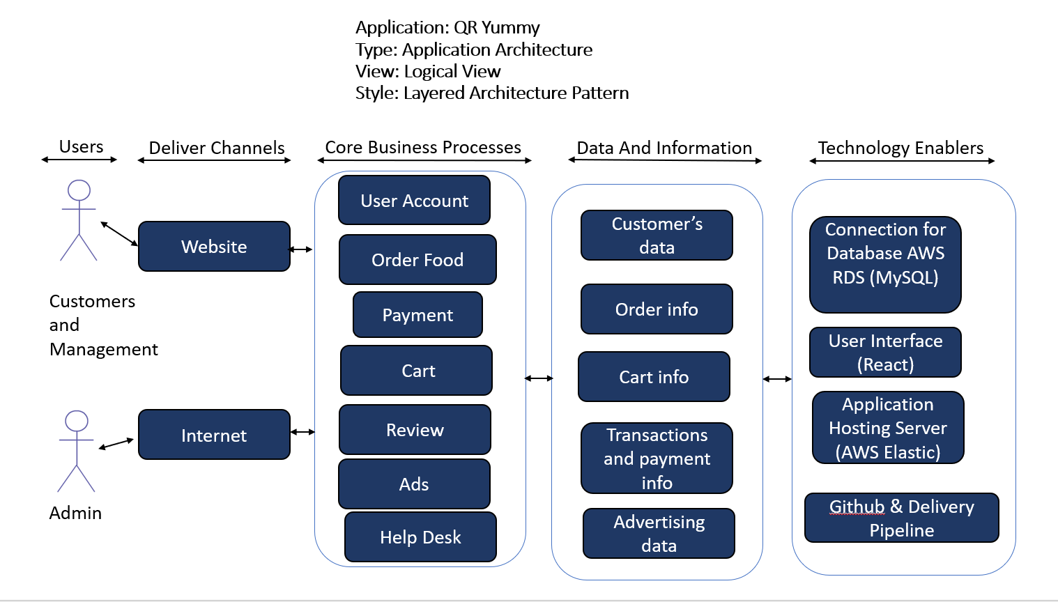

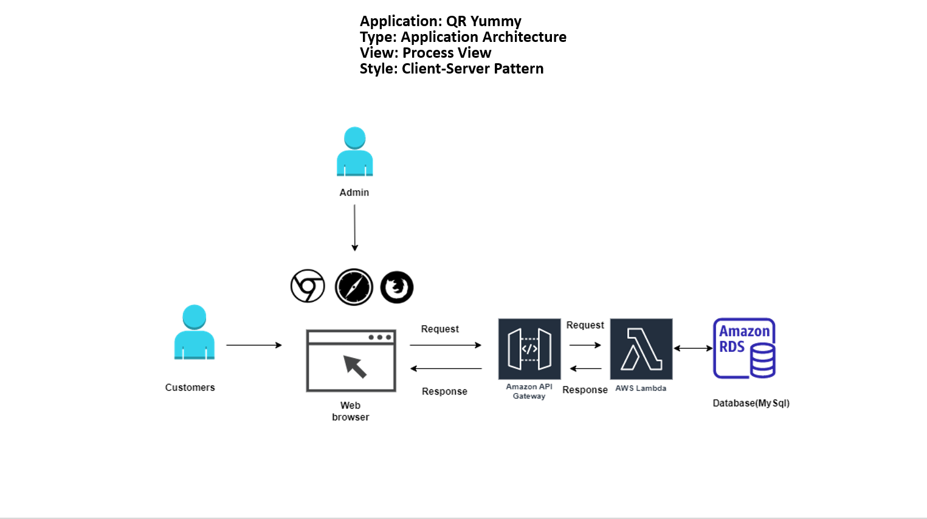

# ROLES AND RESPONSIBILITIES

The project team has seven members that are assigned various project roles including Project Manager, Product Owner, Lead Business Analyst, Lead Developer, DBA, Lead QA Analyst. Their responsibilities are defined in the table below.

| **Project Role** | **Role Responsibilities** |
| --- | --- |
| Project Manager | Reviewing and giving the test plan approval. |
| Lead QA Analyst | Designing a test plan and test specifications. Testing for defects. |
| Product Owner | Contributing to the test plan and test case specifications. Reviewing test results. |
| Lead Business Analyst | Contributing to the test plan and test case specifications. Reviewing test results. |
| Lead Developer | Establishing and maintaining the test environment, assisting a Lead QA Analyst throughout the testing process. |
| DBA | Assisting the Lead Developer in establishing and maintaining the test environment. |

# TEST CYCLES AND SCHEDULE

The system test execution will be conducted as three test cycles that are aligned with three application modules as follows:

Cycle 1.

* This cycle concentrates on testing the QR scanner module.

Cycle 2.

* This cycle concentrates on testing the first part (registering and logging in) of the User Account.

Cycle 3.

* This cycle concentrates on testing the second part (Modifying account details and account deletion) of the User Account.

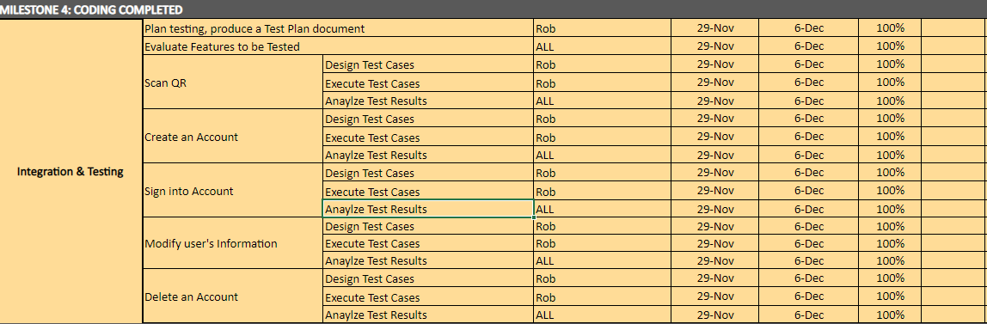

# RISKS AND CONTINGENCIES

This section highlights potential risks and contingencies that may happen during the system testing process.

* Defects that either take up time to resolve due to complexity or a wide amount of defects that take up time to track down and fix.
* Lack of feedback and communication between team members during the testing processes could cause significant delays.
* Changes to the test scope could cause a delay, either due to extra work or confusion because of new changes not properly communicated.